University Of Engineering and Technology, Lahore
Computer Engineering Department

Course Name: Programming Fundamentals | Course Code: CMPE-112L
Assignment Type: Lab tasks | Dated: 4 May 2026
Semester: First | Session: 2026 Spring
Lab/Project/Assignment #: 1 | CLOs to be covered: CLO 3
Lab Title: Sets, Dictionary | Teacher Name: Hafiz Muhammad Mubashar
Lab Evaluation:

CLO3 | Apply appropriate programming techniques to create executable programs to solve well defined problems
CLO3 | Level1 | Level2 | Level3 | Level4 | Level5 | Level6
(5)
Total |  |  |  |  |  | /5
Rubrics for Current Lab Evaluation
Scale | Marks | Level | Rubric
Excellent | 5 | L1 | Submitted all lab tasks, BONUS task, have good understanding.
Very Good | 4 | L2 | Submitted the lab tasks but have good understanding
Good | 3 | L3 | Submitted the lab tasks but have weak understanding.
Basic | 2 | L4 | Submitted the lab tasks but have no understanding.
Barely Acceptable | 1 | L5 | Submitted only one lab task.
Not Acceptable | 0 | L6 | Did not attempt
Week 8 LAB
Sets, Dictionary
Lab Goals/Objectives:
• To understand, create, and manipulate Unordered Collections in Python using Dictionaries and Sets.
• To master key-value mapping logic and dictionary mutability.
• To utilize set mathematical operations (unions, intersections, subsets) and enforce element uniqueness.
Equipment Required:

* Computer/Laptop
* Python 3.14
* VS Code or pycharm

Theory:
Python provides specialized built-in data types for managing unordered collections where positional indexing does not apply.

Lab Work:

Task 1: Dictionary Mapping, Access, and Key-Value Insertion
a = {"apple": "seab", "banana": "kela", "Mango": "aaammmmm"}
print(a["apple"])
a["dates"] = "khajour"
Result:

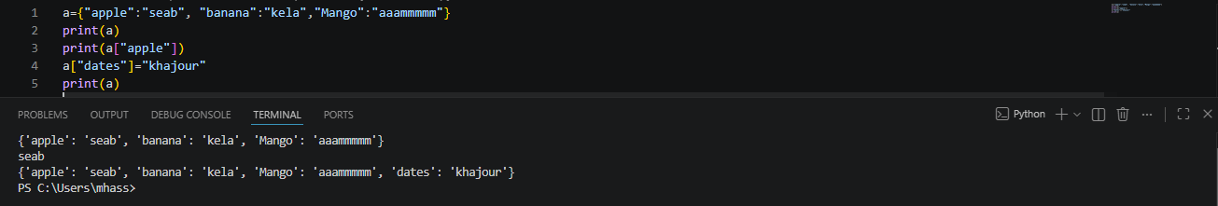

Task 2: Enforcing Set Uniqueness (Duplicate Elimination)
s = {"ali", "ali"}
print(s)

Result:

Task 3: Evaluating Default Empty Braces Type (dict).

s = {}
print(type(s))

Result:

Task 4: Explicit Initialization of an Empty Set.

s = set()
print(type(s))

Result:

Task 5: Iterating Over Sets and Conditional Membership Membership Testing
for i in s:
print(i)
if "CE" in s:
print("CE Exist in the set")
Result:

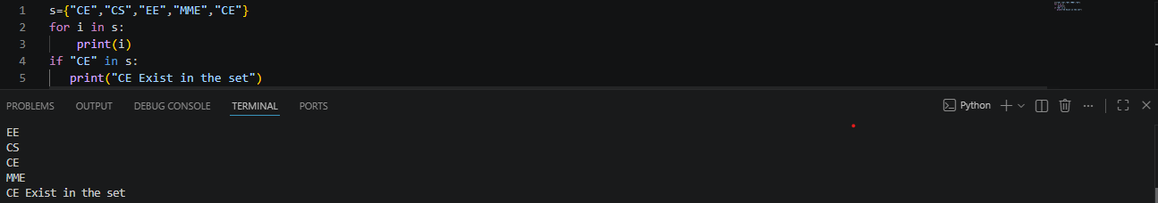

Task 6: Case-Insensitive String Matching using Set Lookups

a = input("Enter Student name=").upper()
if a in s:
print("YES student is present")

Result:

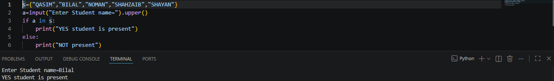
Task 7: Practical Testing of Mutating Set Methods

s.add(4)
s.remove("Bilal")
s.discard("Qasim")
s.pop()
s.clear()

Result:
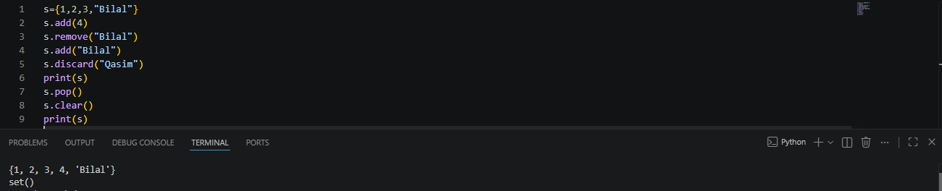
Task 8: Standard Set Union Operation

print(set.union(s1, s2))

Result:
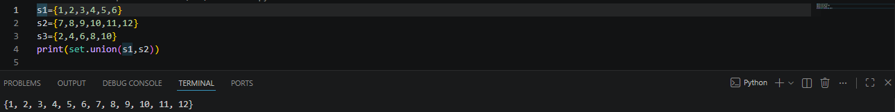
Task 9: Advanced Set Algebra (Intersections, Disjoint Checks, Subsets, and Symmetric Differences)
s2.update(s3)
print(set.intersection(s1, s2))
s1.intersection_update(s2)
print(s2.isdisjoint(s3))
print(s1.issubset(s2))
print(s1.symmetric_difference(s2))
Result:

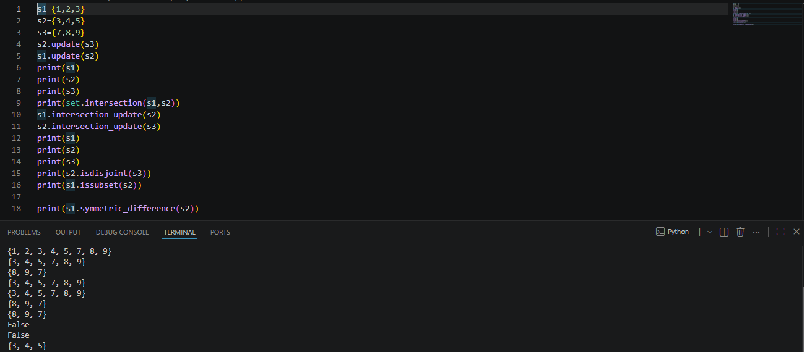

Task 10: Type Casting an Ordered List into an Unordered Set
s = set([1, 2, 3, 4])
print(s)
Result:

Conclusions:
This lab successfully demonstrates the behaviors of hashed, unordered structures in Python. We explored dictionaries as efficient key-value relational maps and sets as powerful mathematical tools. By working through uniqueness constraints, set mutations, and relational operations (like intersections and subsets), we established how to manage collection data where element identity and membership override numerical index positions.

